SOLENT UNIVERSITY   
**Faculty of Business, Law and Digital Technologies**

Foundation

**Academic Year 2020-2021**

**Filipe Quartin**

**Personal Learning Record**

Assignment 1

**Foundation Computing – COM 304**

**Tutor: [NAME HERE] [DATE HERE]**

Contents

Topic (to be renamed accordingly) 4

Topic … (to be renamed accordingly) 4

Conclusion 4

References 4

Appendices 4

Introduction:

This report is being written in result of the first assessment for foundation computing where it will be related to the subjects taught in class.

The subjects are simple but encompasses almost all topics needed to have basic computer skills, From hardware, software and cloud computing.

I believe that this only serves to ensure that students are all at roughly the same level.

1 Computer structure and functioning:

* 1. First Computer :

To have an easy comprehension about the computer’s hardware structure and functioning we have to remount a little bit in history, back in the time of the first’s computers.

The first computer called ENIAC[Electronic Numeral Integrator and Computer](fig1) was built in 1943-1946

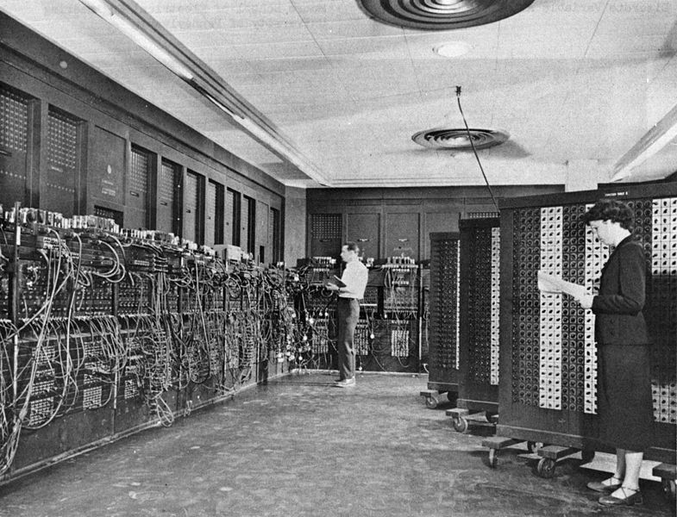

*Fig1:the ENIAC machine*

John von Newman was working as a consulter in the eniac project. In 1945 Newman proposed the construction of a new computer called the EDV AC (Electronic Discrete Variable Computer). Later in 1946 Newman and his crew started building the IAS computer, at the Princeton Institute for Advanced Studies. In this computer he used the structure that he proposed in 1945. This model stayed in history as the von Newman .

The structure of the von Newman was revolutionary , becoming the prototype of all subsequent general-purpose computers.(fig2)

(for more information about the IAS please consult the following link: [https://www.coursehero.com/file/49224435/Lecture-2pptx/](https://www.coursehero.com/file/49224435/Lecture-2pptx/%20) )

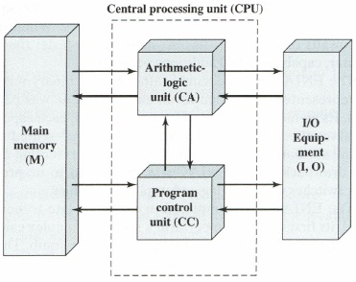

*´ Fig2:Structure of von newman machin*

1.2 Bus interconnection:

A bus line is a silicium line incorporated in the motherboard that have the job to establish a connection line between etch one of the hardware components with the CPU.

The bus lines can differ in 3 types:

* Control line
* Access line
* Data line

(for more information please consult the flowing link: https://quickcse.wordpress.com/2018/07/11/bus-interconnection/)

# Topic (to be renamed accordingly)

# Topic … (to be renamed accordingly)

# Conclusion

# References

# Appendices

# 